De Soto High School
Choral Handbook

2014-2015
Aaron Young, Head Choral Director
Suzanne Harris, Assistant Choral Director

Contains philosophy, requirements, and calendar for the choral ensembles offered in grades 9-12 in the De Soto School District #73.

Welcome to High School Choir

I am anticipating an exciting year with many wonderful musical opportunities. Below are some necessary items your child needs to begin the year successfully.
Necessary items for chorus:
- A sharpened pencil
- A folder to keep any handouts or assignments
- Lined, notebook paper (5-10 sheets) for the folder
- A uniform for choir concerts, festivals, and other choral events (explained later in the handbook)
- A Student Handbook/Assignment Book brought to each class period

Choral Handbook

This handbook contains our philosophy, choir attendance policy, uniform requirements, and choral calendar. The back of the handbook contains information sheets that I ask students and parents to fill out together. The sheets are due back Wednesday, August 27, 2014.

Information needed by Wednesday, August 27, 2014:
- Student Information form
- Permission Trip form for choir field trips
- Handbook contract
- T-shirt order form (only if you would like to buy one)

Please fill out the above information and tear those sheets from the Handbook. Please keep the rest of the handbook for your records.
We look forward to teaching your child. We are planning an exciting year!

Sincerely,

Mr. Aaron Young Mrs. Suzanne Harris
Choral Director Assistant Choral Director
De Soto High School De Soto High School

Music Education Goals

- The student will develop a degree of musical independence, which will enable him/her to read and perform music. This skill is referred to as music literacy.

- The student will study representative examples of music from the various stylistic periods of music history, including music composed by the recognized master composers.

- Students will develop and understand a classical vocal technique based on the Italian bel canto style of singing.

- The student will participate in musical activities that are designed to stimulate aesthetic response.

Music is a performing art. Students must participate in the act of performance to fully realize and experience the musical and aesthetic values of the discipline. In addition, an audience is an essential part of a performance and is required for the highest realization of the values intrinsic to the musical experience.
DISCIPLINE AND A POSITIVE ATTITUDE:

The most important characteristics of fine choral singers!!!

The Importance of Discipline: The nature of the music organization requires strict discipline. Students and parents should be willing to accept ideals, principles and rules of the organization.
Choir members are frequently on display and each must be aware of the importance of good behavior. Students should remember that they represent their organization, school, and community whenever they perform or appear publicly. Any misconduct casts a direct reflection on our school and community and may well undo the good work of many loyal students.
A successful ensemble experience is built on discipline. Discipline is order and with order comes the attainment of worthy goals.

The Importance of a Positive Attitude: The greatest single factor that will determine the success of any individual is attitude. It takes intense dedication to reach goals. Students should learn to discipline themselves to daily practice, sight singing, and part study in concentrated and routine practice.
As Robert Henri, a renowned teacher of art, observed: “Everything depends on the attitude of the artist toward his subject. It is the one essential.” The attitude makes an artistic performance inevitable and is the factor that makes the difference between a musical organization and a group of people who just sing together.
Approach each new piece of music by asking these questions: What can I make out of this? What are the musical phrases trying to say? Am I giving every last effort to make my part contribute to the whole sound of the ensemble? This is the attitude of the true musician.
By acknowledging the discipline of music, we can challenge the boundaries of our limited perception and really appreciate the beauty of life. Analyze your own attitude and try to develop more receptivity. Make the most out of every performance.

CLASSROOM POLICIES

DISCIPLINE

The choral program will utilize the discipline policy set forth by the De Soto School District No. 73.
As choir begins:
- Be on time, bring a pencil, and your Student Handbook
- Be in your assigned seat/standing position
- Have your music in order
- Dispose of any gum or food upon entering the room

During class:
- Respect your rights and the rights of others to learn
- Give your best effort
- Listen
- Follow directions
- Mark your music (pencil only)
- Maintain good body position for good singing at all times

At the end of Class/Rehearsal:
- Pick up around your assigned seat/standing position
- Help put the room back in order
- Put your folder in its assigned location

CONSEQUENCES (per quarter)

First infraction Warning (participation points deducted)
Second infraction Stay after class one minute
Third infraction Ten minute morning detention (Parent Contact)
Fourth infraction Write up or after school detention
Severe Clause Write up – Sent directly to office

GRADING POLICY

Evaluations will be based on attitude, effort/improvement, music literacy tests and quizzes, attendance at all required events, and any special projects assigned. Parents are encouraged to consult the director at any time in regard to their son’s or daughter’s progress. A close contact between parents and the Director will indicate a strong interest in the music program and can aid both parties in understanding and problem solving.
The following areas will be the focus of instruction:
- Music Literacy and Theory (including the instruction of solfege)
- Vocal Technique
- Music History and Culture
- Ensemble Skills
- Cultivation of an aesthetic appreciation of the art form
- Positive participation

Grades will be based on the same grading scale as mandated by the De Soto Public School District No. 73.
Grading Criteria (per quarter):
Worksheets/Quizzes/Tests/Part Sing off 30 %
Daily Preparation/Participation 20%
Concert Attendance 50%
COMMUNICATIONS
It is of utmost importance that parents and students have many viable means of communication with the choral directors. Listed below are means for parents/students to contact the choral directors.
- For high school choral information:
Choir room: 586-6250, Athletic/Activity Office: 586-1058, DHS Main Office: 586-1050
- Email: young.aaron@desoto.k12.mo.us and harris.suzanne@desoto.k12.mo.us

3. Like the De Soto Choirs page on Facebook.

4. Follow @DHSChoirs on Twitter.

5. Remind 101

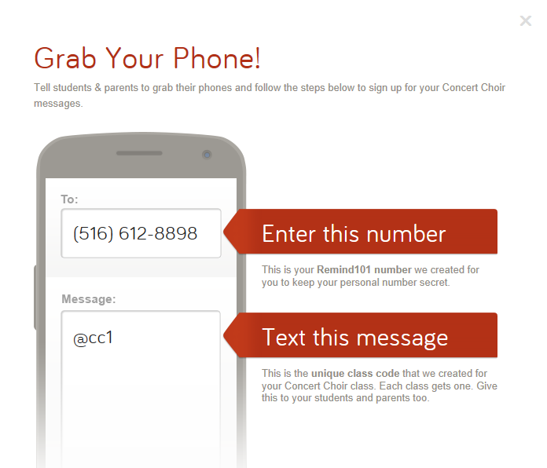
516-252-0426

The picture above is for Concert Choir, but I have created a separate section for each class. Using the same number as listed above 516-252-0426 text the following codes for your class and receive text messages from Mr. Young with important reminders and information (you can also use email if you prefer):
Concert Choir: @cc1 email: send an email to cc1@mail.remind.com
Men’s Glee: @mg1 email: mg1@mail.remind.com
Women’s Glee: @wg1 email: wg1@mail.remind.com
Chamber Choir/Vocal Jazz: @chamberch email: chamberch@mail.remind.com
6. De Soto Choir webpage: http://www.edline.net/pages/DeSotoHighSchool/Classes/Music_10033

ATTENDANCE

Performance Attendance:
All performances are required for curricular choirs. A calendar of required performances is enclosed in the following pages. Students will only be excused in case of an extreme family emergency or illness. The teacher must have a doctor’s written excuse and/or a parent note explaining the situation. The teacher will assess the situation, discuss with his administrators, and if warranted, give an alternate assignment. Alternate assignments will not be issued for unexcused absences, as the students will not receive credit for unexcused absences.
Daily Attendance:
Students are required to be at all rehearsals. For curricular choirs, tardies and absences from daily class sessions will be handled as mandated by the De Soto High School Student Handbook.

UNIFORMS

Concert Choir | Women’s Glee | Men’s Glee
*Rental fee: $10.00  Men will need to provide black pants, black socks, black dress shoes, and a white button-up dress shirt.  Women will need to provide nude or beige knee-high’s and black dress shoes. They will also be expected to have their dress hemmed. We will also discuss the possibility of purchasing white blouses. | *Rental fee: $6.00  Women will need to provide nude or beige knee-high’s and black dress shoes. They will also be expected to have their dress hemmed. | *Rental fee: $4.00  Men will need to provide a plain white undershirt  (t-shirt), black trousers (no jeans), black socks, and black dress shoes.

*The rental fee will cover the cost of having the uniforms that we provide dry cleaned and/or repaired due to wear and tear.
All uniforms that are provided will be turned in after our last performance of the school year.
De Soto High School Choir Event Calendar
2014-2015
Date | Event | Place/Time | Who is involved?
Monday, Sept. 1, 2014 | Cardinals Game Performance of GBA | Busch Stadium  Game time is 1:15 PM | Concert Choir
Monday, Sept. 29, 2014 | MMEA All-District Auditions | Hillsboro HS  3:00 PM – 8:00 PM | Interested students
Sunday, Oct. 19, 2014 | HS Fall Choir Concert | DHS Gym  3:00 PM | ALL CHOIR STUDENTS
Tuesday, Nov.11, 2014 | Veteran’s Day Assembly | DHS Gym  During the school day | Concert Choir
Tuesday, Nov. 11, 2014 | MMEA All-District Choir Rehearsal | Hillsboro HS  5:30 PM – 8:30 PM | All-District Choir Members
Saturday, Nov. 15, 2014 | MMEA All-District Choir Performance | Rickman Auditorium  All Day | All-District Choir Members
Friday, Dec. 5 – Sunday, Dec. 7, 2014 | Holiday Festival of Choir at WIU | WIU, Macomb, IL | Chamber Choir
Sunday, Dec. 14, 2014 | Christmas Concert and Dessert Auction | DHS Gym  3:00 PM – 6:00 PM | ALL CHOIR STUDENTS
Saturday, Dec. 20, 2014 | Christmas Caroling | St. Andrews Methodist on Rock Rd. 5 – 7:30 PM | Interested students
Wednesday, Jan. 21 – Saturday, Jan. 24, 2015 | MMEA All-State | Tan-tar-a Resort, Osage Beach, MO | Selected students
Sunday, February 15, 2015 | Solo and Ensemble Vocal Recital | TBD | All soloists and ensembles
Saturday, March 7, 2015 | MSHSAA Solo and Ensemble Contest | Jefferson C. C., Hillsboro - All Day | All soloists and ensembles
Thursday, March 12 – Sat., March 14, 2015 | HS Musical | DJHS Gym | Interested Students
Wed., March 25, or Thurs., March 26, 2015 | MSHSAA Large Ensemble Contest | Jefferson C. C., Hillsboro Time-TBA | ALL CHOIR STUDENTS
Friday, May 1 – Sunday, May 3, 2015 | Concert Choir trip to Oklahoma City, OK | Oklahoma, OK | Concert Choir
May 2015 (exact date TBD) | HS Spring Choir Concert | DHS Gym | ALL CHOIR STUDENTS
Wednesday, May 6, 2015 | DHS Baccalaureate | DHS Gym  TBA | Concert Choir
Saturday, May 9, 2015 | Six Flags Festival | Six Flags, Eureka, MO  All Day | Men’s and Women’s Glee
The calendar is subject to change. If a change is made, students and parents will be notified in a timely fashion.

T-shirt order form
T-Shirt Order Form

The choir program will order t-shirts this year and they will cost $10.00 (sizes S-XL, $11.50 for XXL or larger). Here is the design (on a heather gray tshirt):

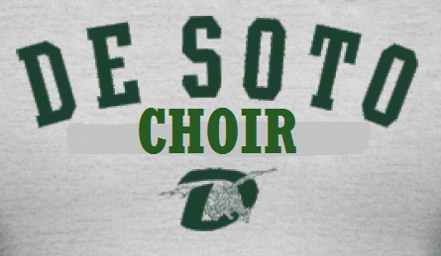

If you would like to order a shirt please fill out the information below and bring the bottom portion back to Mr. Young my Wednesday, August 27, 2014.

Student name:______________________________________________

Adult size (please circle the size that you would like and indicate the quantity on the line underneath.

S M L XL XXL other ______

____ ____ ____ ____ ____ ____

Please make checks payable to DHS.

Student Information Form
(please print clearly)

PLEASE RETURN BY WEDNESDAY, AUGUST 27, 2014

Student Name:__________________________________________________________________

Grade in School (please circle): 9 10 11 12

Choir (please circle all that apply): Women’s Glee (3rd) Women’s Glee (4th)

Concert Choir Men’s Glee

Date of Birth:__________________________________________________________________

Locker Number:________________________________________________________________

Parent’s Primary Email Address:___________________________________________________

Father’s Full Name:_____________________________________________________________

Mother’s Full Name:_____________________________________________________________

Your Home Address:____________________________________________________________
(house/apt.#, street, city, and zip code)

Your Home Phone:______________________________________________________________

Father’s work and/or Cell Phone:___________________________________________________

Mother’s work and/or Cell Phone:__________________________________________________

If your parents are divorced, with whom do you live?___________________________________

The Choral Handbook Contract for 2014-2015

PLEASE RETURN BY WEDNESDAY, AUGUST 27, 2014

Student Contract of____________________________
(print name of student)

The undersigned confirm that they have read and understand all of the information contained within the De Soto High School Choral Handbook. It is understood that all the rules and regulation will apply during any music function sponsored by De Soto Public School District No. 73. The undersigned agree to make any and all necessary arrangements to attend each function.

The undersigned understand that maintaining scholastic eligibility is required for participation in all music activities. The student assumes responsibility for reading the De Soto High School Student Handbook and all rules contained therein. In addition, the undersigned student and parents understand that any rules set forth by the De Soto Public School District No. 73 will be binding on the student.

Signature of the Student

_____________________________ Date_________________

Signature of the Parent/Guardian

_____________________________ Date_________________

Permission Slip for Choir Trips and Contests
As members of the choral program, students will use district transportation to attend choral activities. These trips include being shuttled to another school building for rehearsals and concerts, traveling to music contests, community concerts, and enrichment activities. Prior to each individual outing students will receive information describing the purpose of the trip, arrival and departure times, and other pertinent information. To consolidate paperwork, the choral department asks that you sign a permission slip covering all of the day trips for the entire school year. This form does not cover any trips that might include overnight stays.

My son/daughter______________________has my permission to attend choral field trips in the 2014-2015 school year. I further understand that if my child is involved in any discipline problem he/she will be treated as if attending regular school activities or classes on campus.

Signature of the Parent/Guardian

_____________________________ Date_________________

